**Leitura de XML**

**Gerando um arquivo XSD schema a partir do XML**

[**https://www.freeformatter.com/xsd-generator.html**](https://www.freeformatter.com/xsd-generator.html)

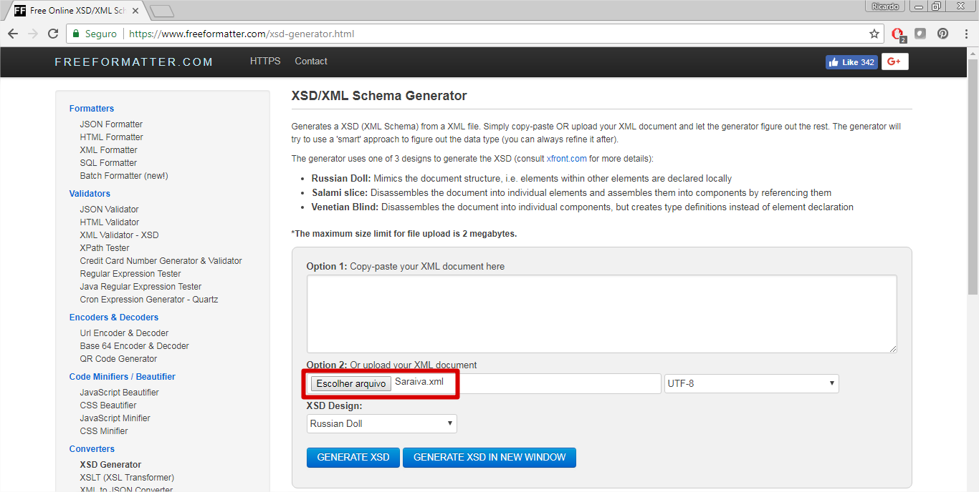



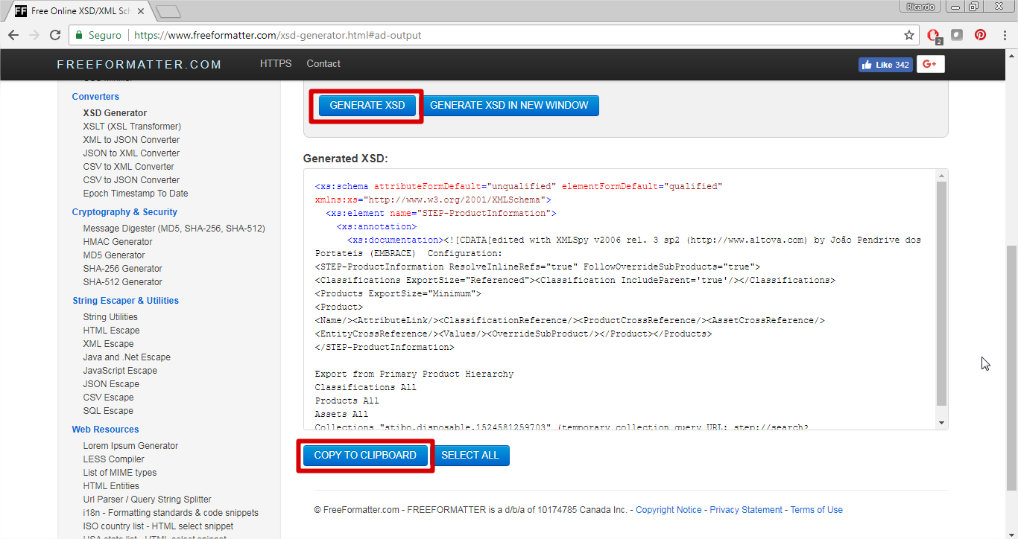



**ou com o Visual Studio**

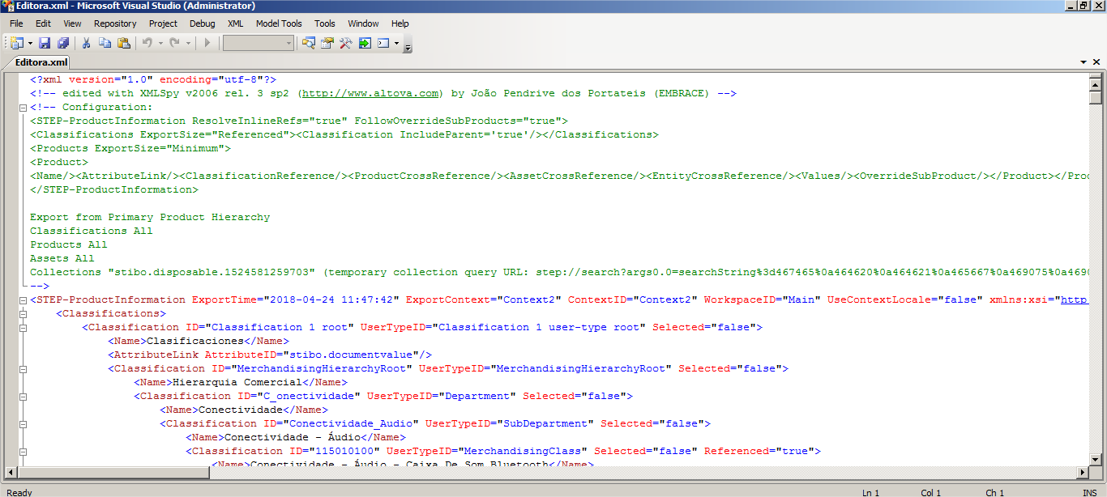

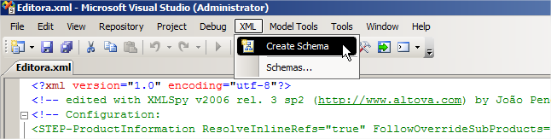

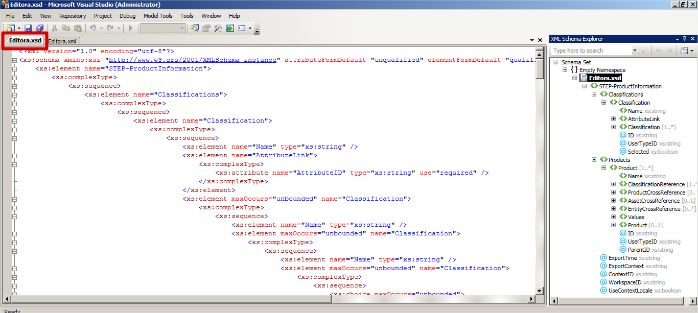

**Criando o XSD Schema no Data Services**

